Virtual Reality Or New Reality?

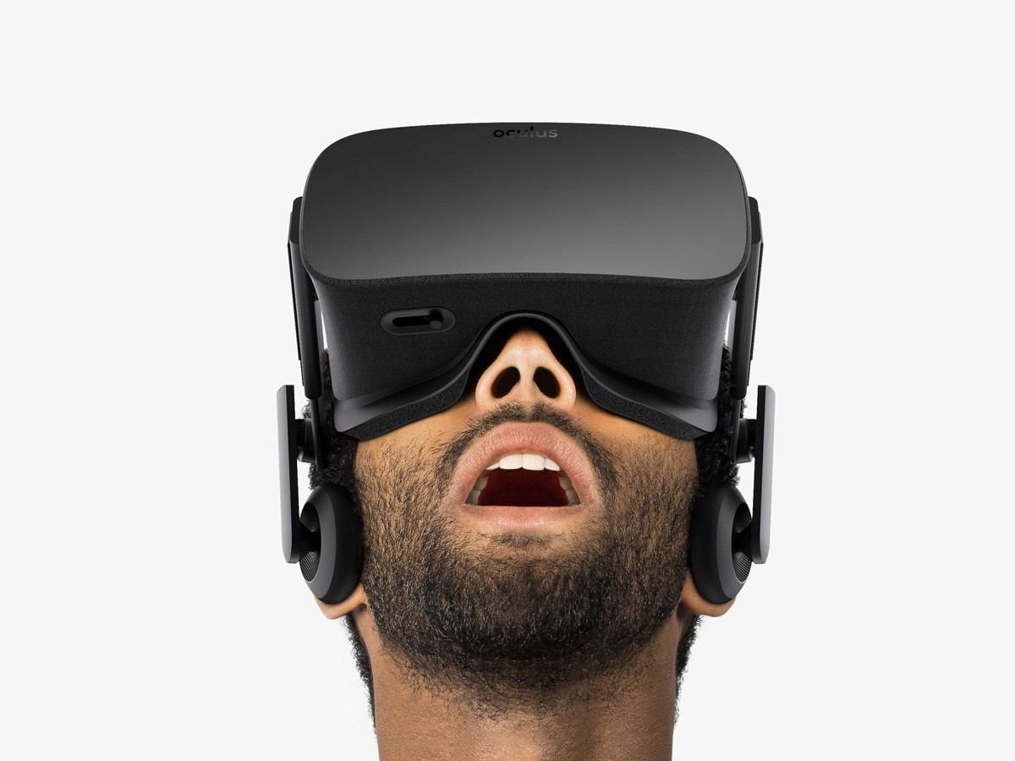

The Virtual Reality, or VR if you will, revolution that is currently upon us, is about much, much more than just video games.
VR will challenge our understanding of reality.
While VR is obviously poised to change the way that we not only play but also experience games, by placing us in the games with a full 3D world all around us, VR, which has been around since the 1970s, attempts to, using an immersive multimedia experience, create/ simulate a physical presence.
Meanwhile, albeit in a brick-and-mortar setting, fully immersive VR is already being used, in what was a clever marketing campaign, McDonald’s gave its customers VR headsets and transported them inside a Happy Meal box. Armed with a virtual paintbrush, they decorated the box in wild colours, while surrounded by all the contents of a Happy Meal.
For VR to be able to deliver that immersive experience a considerable amount of GPU processing power is required. As an example, the upcoming Oculus Rift will run at 2160x1200, at 90 frames per second, however, if a consistent 90 frames per second cannot be maintained the game will stutter and input lag will occur, ruining the experience, straining eyes, and potentially causing headaches.
The future for VR, with Facebook’s purchase of Oculus Rift for $2 billion in 2014, seems more social.
Virtual Reality looks like it is a trend that is well on its way to becoming a part of our daily lives.
Roger
Sources:
Time.com
Changes-of-tomorrow.hyperisland.com
GeForce.com

